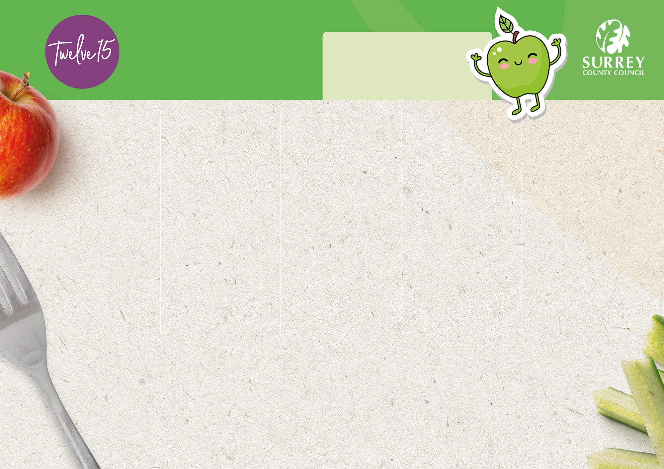
Weeks Starting:
21st April, 12th May,
9th June, 30th June,
21st July, 15th September
and 6th October
Week 1

Spring/Summer 2025 Menu

Monday
Friday
Thursday
Wednesday
Tuesday


Option 1
Option 1
Option 1
Option 1
Option 1

Fish Fingers with Oven Chips
Beef Pasta Bolognese
Roast Chicken with Roast Potatoes and Gravy
Chicken and Five Veg Meatballs in Tomato Sauce with Couscous
Cheese and
Tomato Pizza with Potato Tots

Option 2
Option 2
Option 2
Option 2
Option 2

Cheese and Tomato Swirl with Oven Chips
Vegan Pasta Bolognese
Roasted Vegetable Parcel with Roast Potatoes and Gravy
Veggie Meatballs in Tomato Sauce with Couscous
Butternut Squash Mac ‘n’ Cheese

Option 3
Option 3
Option 3
Option 3
Option 3
Tuna Wrap
Cheese Wrap

Ham Wrap

Jacket Potato and Baked Beans

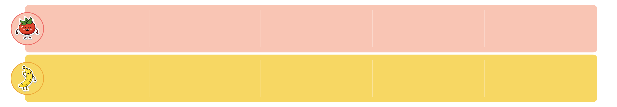

Sides:

Sides:

Sides:

Sides:

Sides:

Seasonal Vegetables, & Fresh Bread
Seasonal Vegetables, & Fresh Bread
Seasonal Vegetables, Salad Bar
& Fresh Bread
Seasonal Vegetables, Salad Bar
& Fresh Bread
Seasonal Vegetables, Salad Bar
& Fresh Bread


Dessert:

Dessert:

Dessert:
:

Dessert:
:

Dessert:
:

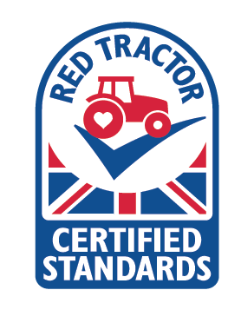
Fresh Dairy
Yoghurt
Peaches with
Vanilla Yoghurt
Apple Sponge
with Custard
Vanilla
Ice Cream
Chocolate
Cookie

Vegetarian
Contains a minimum of 50% fruit
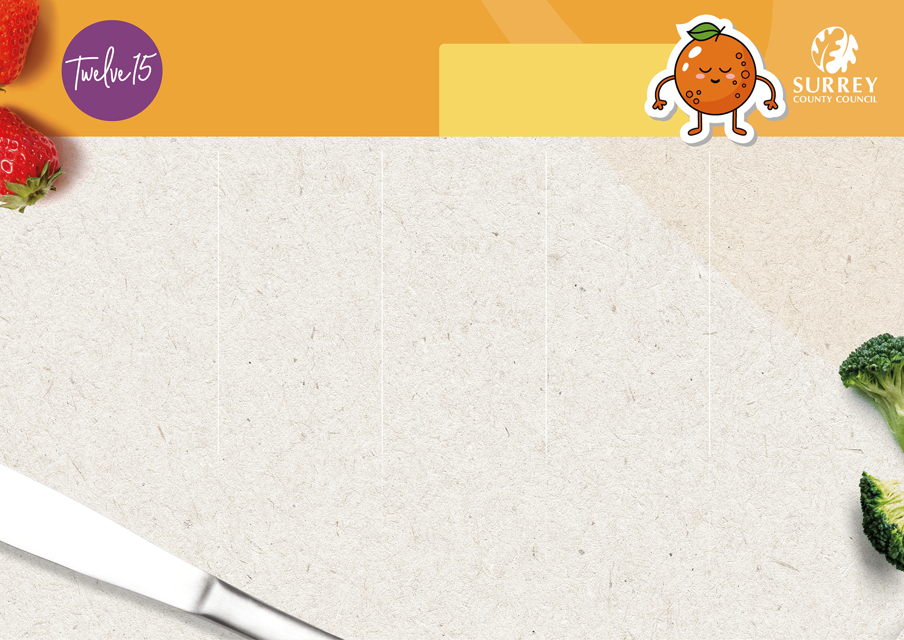
Weeks Starting:
28th April, 19th May, 16th June,
7th July, 1st September,
22nd September
and 13th October

Week 2

Spring/Summer 2025 Menu

Friday
Thursday
Wednesday
Tuesday
Monday

Option 1
Option 1
Option 1
Option 1
Option 1

Cheese and
Tomato Pasta Bake
Chicken Burger with Potato Tots
Roast Pork with Roast Potatoes and Gravy
Creamy Chicken and Sweetcorn with Rice
Harry Ramsden’s Fish with Oven Chips

Option 2
Option 2
Option 2
Option 2
Option 2

Veggie
Burrito
Glamorgan Sausage with Roast Potatoes and Gravy
Southern Style Quorn Burger
with Potato Tots
Veggie Sausage and Tomato Roll with Potato Tots
Vegetable Fingers with Oven Chips

Tuna Wrap
Cheese Wrap

Ham Wrap
Option 3
Option 3
Option 3
Option 3
Option 3

Jacket Potato and Baked Beans

Sides:

Sides:

Sides:

Sides:

Sides:

Seasonal Vegetables, & Fresh Bread
Seasonal Vegetables, & Fresh Bread
Seasonal Vegetables, Salad Bar
& Fresh Bread
Seasonal Vegetables, Salad Bar
& Fresh Bread
Seasonal Vegetables, Salad Bar
& Fresh Bread

Dessert:
:

Dessert:
:

Dessert:

Dessert:
:

Dessert:

Frozen Yoghurt
with Mango
Fruit
Jelly
Vanilla Sponge
with Custard
Chocolate
Mousse
Shortbread Biscuit with Fresh Fruit Slices

Vegetarian
Contains a minimum of 50% fruit
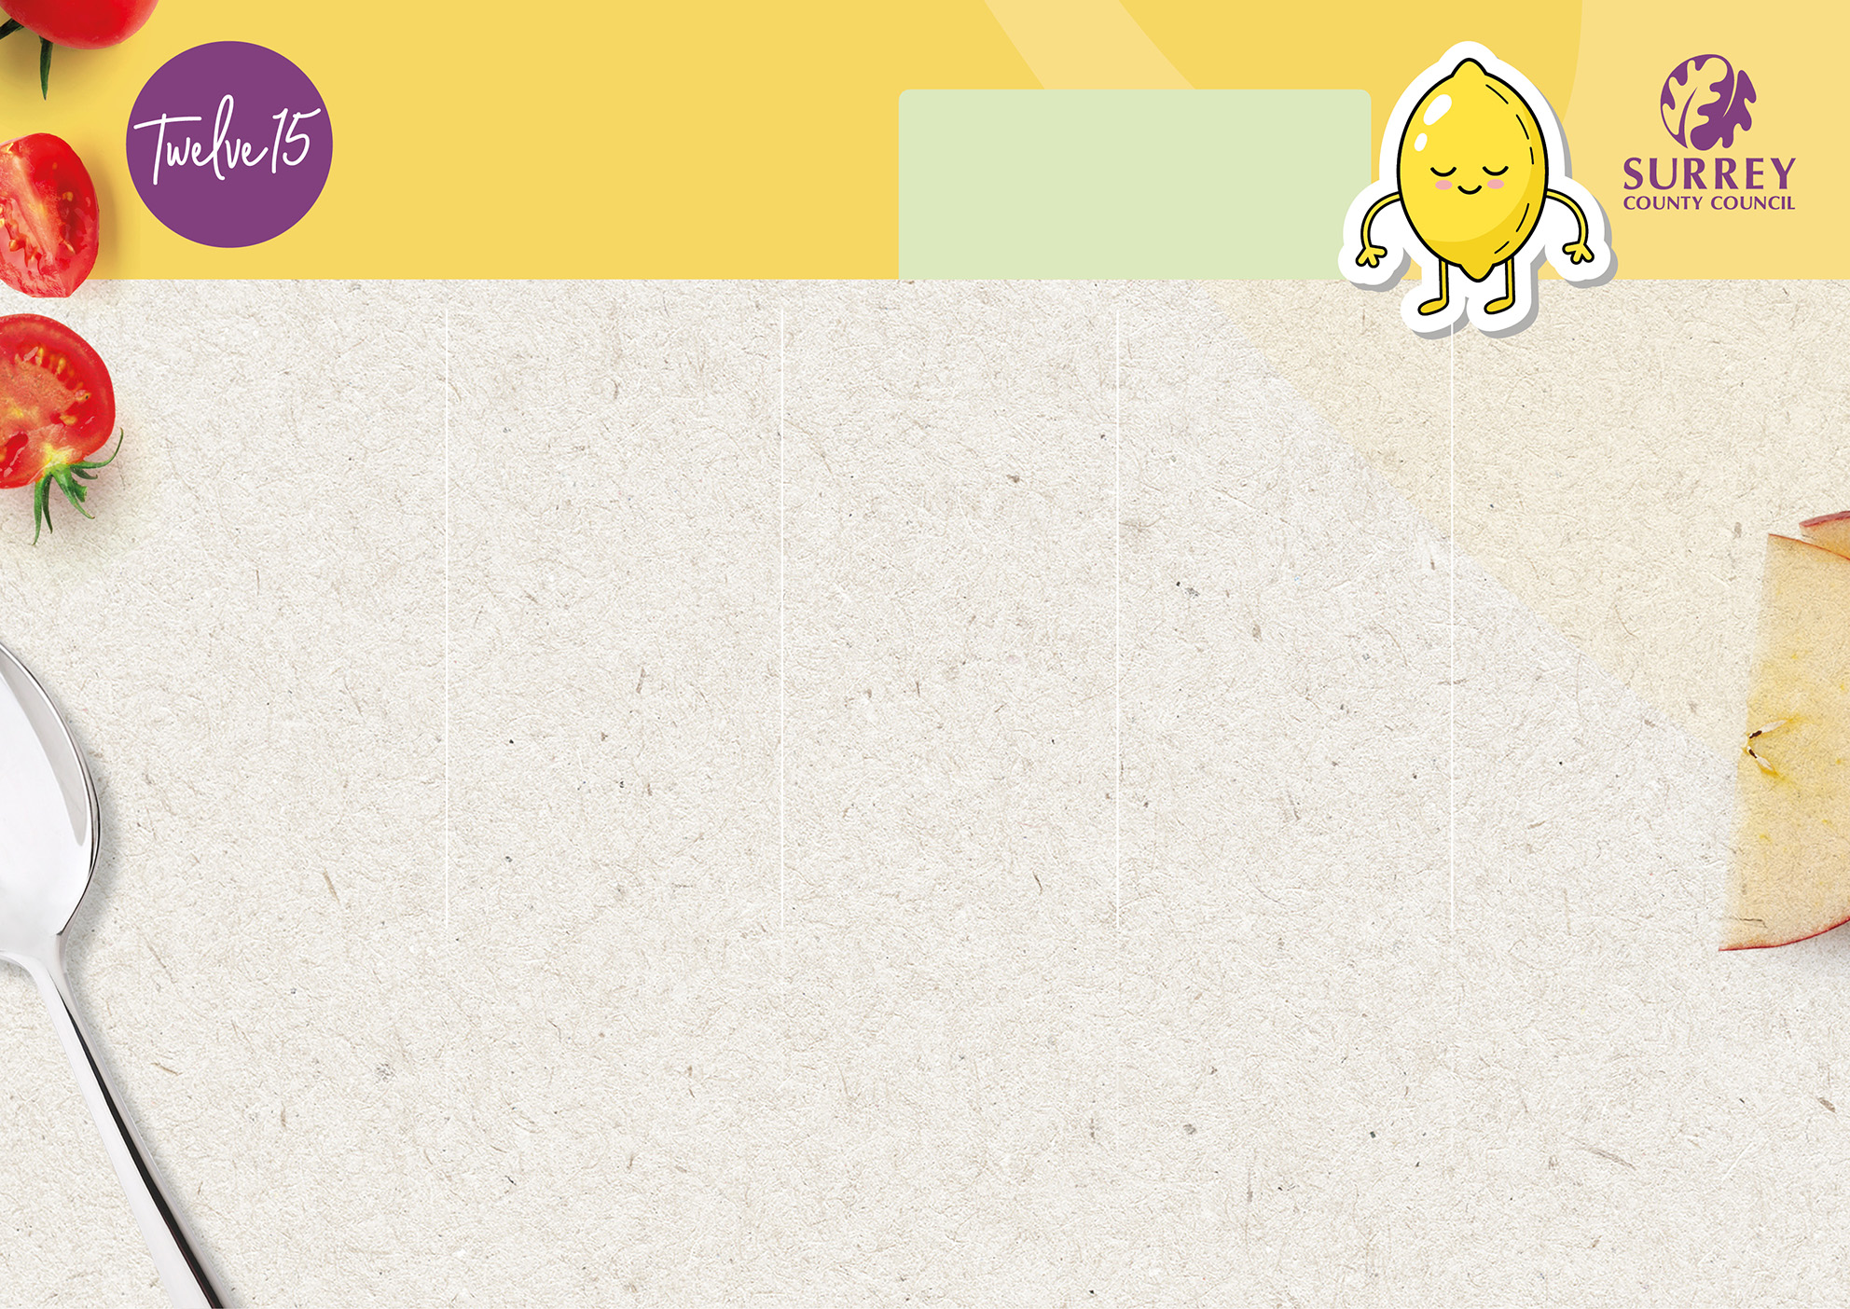
Weeks Starting:
5th May, 2nd June, 23rd June,
14th July, 8th September,
29th September
and 20th October

Week 3

Jacket Potato and Baked Beans
Dessert:

Dessert:

Dessert:
:

Dessert:
:

Dessert:
:

Raspberry Ripple
Ice Cream Roll
Vegetarian
Contains a minimum of 50% fruit
Sides:

Sides:

Sides:

Sides:

Sides:

Friday
Thursday
Wednesday
Tuesday
Monday
Spring/Summer 2025 Menu
Lemon
Shortbread
Pear Sponge
with Custard
Fresh Dairy
Yoghurt
Fresh Fruit Salad
with Vanilla Yoghurt
Option 1
Option 2
Option 2
Option 2
Option 2
Option 2
Roast Chicken
with Roast Potatoes and Gravy
Veggie
Dippers with
Oven Chips
Southern Style Quorn Katsu Curry with Rice
Vegan Sausage Cutlet with Roast Potatoes and Gravy
Quorn Sausage with Creamed Potato and Gravy
Mediterranean
Vegetable Pasta
Fish Fingers with Oven Chips
Chicken Katsu
Curry with Rice
Pork Sausages with Creamed Potato and Gravy
Veggie Feast Pizza with
Potato Tots
Option 3
Option 3
Option 3
Option 3
Option 3
Tuna Wrap
Cheese Wrap

Ham Wrap
Option 1
Option 1
Option 1
Option 1
Seasonal Vegetables, & Fresh Bread
Seasonal Vegetables, & Fresh Bread
Seasonal Vegetables, Salad Bar
& Fresh Bread
Seasonal Vegetables, Salad Bar
& Fresh Bread
Seasonal Vegetables, Salad Bar
& Fresh Bread

