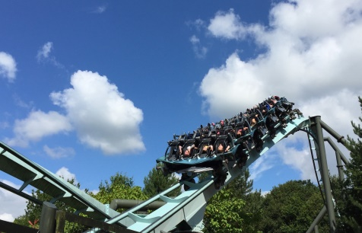
THEME PARK – Stage 2
a
How much will it cost to run your theme park each day?

Daily running costs
Item | Staff Costs | Electricity/  maintenance/  repairs | How many do I have in the park? | Total cost
Major ride | £200 | £250 |  | £
Minor ride | £150 | £200 |  | £
Café | £250 | £120 |  | £
Shop | £120 | £60 |  | £
Toilet | £25 | £25 |  | £
Your Daily Running Cost
£

If you charged £10 per person to enter the theme park, what is the least amount of people you would need to visit each day just to ‘break even’?

Show your working

If 500 people came to your theme park on one day, what would the minimum price you would need to charge each visitor for you to ‘break even’?
What would your answer be to the nearest pound?

Show your working

a
You want to charge a special price of just £4 for the opening week to attract as many visitors as possible. Here is the list of the number of visitors who came to the theme park for this special offer opening week.

Day | Sunday | Monday | Tuesday | Wednesday | Thursday | Friday | Saturday
No. of visitors | 964 | 503 | 387 | 984 | 365 | 689 | 1108

How much profit will you make in this one week?

 | No. of visitors | Each Ticket costs | Total income | Subtract ‘Your Daily Running Cost’
Sunday | 964 | £4 | £
Monday | 503 | £4 | £
Tuesday | 387 | £4 | £
Wednesday | 984 | £4 | £
Thursday | 365 | £4 | £
Friday | 689 | £4 | £
Saturday | 1108 | £4 | £
Total Profit =

Did you make a good decision? Yes / No

Explain your answer.

THEME PARK – Stage 2
b
How much will it cost to run your theme park each day?

Daily running costs
Item | Staff Costs | Electricity/  maintenance/  repairs | How many do I have in the park? | Total cost
Major ride | £200 | £250 |  | £
Minor ride | £150 | £200 |  | £
Café | £250 | £120 |  | £
Shop | £120 | £60 |  | £
Toilet | £25 | £25 |  | £
Your Daily Running Cost
£

If you charged £15 per person to enter the theme park, what is the least amount of people you would need to visit each day just to ‘break even’?

Show your working

If 550 people came to your theme park on one day, what would the minimum price be to charge each visitor for you to ‘break even’?

Show your working

b
You want to charge a special price of just £4 for the opening week to attract as many visitors as possible. Here is the list of the number of visitors who came to the theme park for this special offer opening week.

Day | Sunday | Monday | Tuesday | Wednesday | Thursday | Friday | Saturday
No. of visitors | 964 | 503 | 387 | 984 | 365 | 689 | 1108

How much profit will you make in this one week?

Show your working

Total Profit =

Did you make a good decision? Yes / No

Explain your answer.

THEME PARK – Stage 2
c
How much will it cost to run your theme park each day?

Daily running costs
Item | Staff Costs | Electricity/  maintenance/  repairs | How many do I have in the park? | Total cost
Major ride | £200 | £250 |  | £
Minor ride | £150 | £200 |  | £
Café | £250 | £120 |  | £
Shop | £120 | £60 |  | £
Toilet | £25 | £25 |  | £
Your Daily Running Cost
£

If you charged £18 per person to enter the theme park, what is the least amount of people you would need to visit each day just to ‘break even’?

Show your working

If 555 people came to your theme park on one day, what would the minimum price be to charge each visitor for you to ‘break even’?

Show your working

c
Here are the number of visitors who came to your theme park for your opening week.

Day | Sunday | Monday | Tuesday | Wednesday | Thursday | Friday | Saturday
No. of visitors | 964 | 503 | 387 | 984 | 365 | 689 | 1108

You want to make £25,000 profit in this week. How much would you have to charge each visitor? Remember you have to take in to account your daily running costs.

Show your working

Have you made a realistic target? Yes / No

Please explain.

Extension: How much would you have to charge each visitor to make a profit of £50,000 profit in this week?

